Overview
My background sound unit is a fairly standard Arduino-like controller driving a DFPlayer Mini to play background sound files. However, I chose to use an ESP 8266 chip with built-in Wi-Fi so that I could trigger override sounds remotely. Since I am already using JMRI with my railroad, I wanted to use Wi-Fi throttles via JMRI as the triggering mechanism.

The basic background sound playback simply loops through all mp3 files in folder 01. The code also subscribes to a pair of MQTT topics, one for volume and one for triggering "ads", which are actually thunderstorm mp3 files. The topics are specified in the config file that is included at the top of main.cpp. These topics are defined in the JMRI MQTT preferences, and the messages that are sent are coded into JMRI.

Diagram
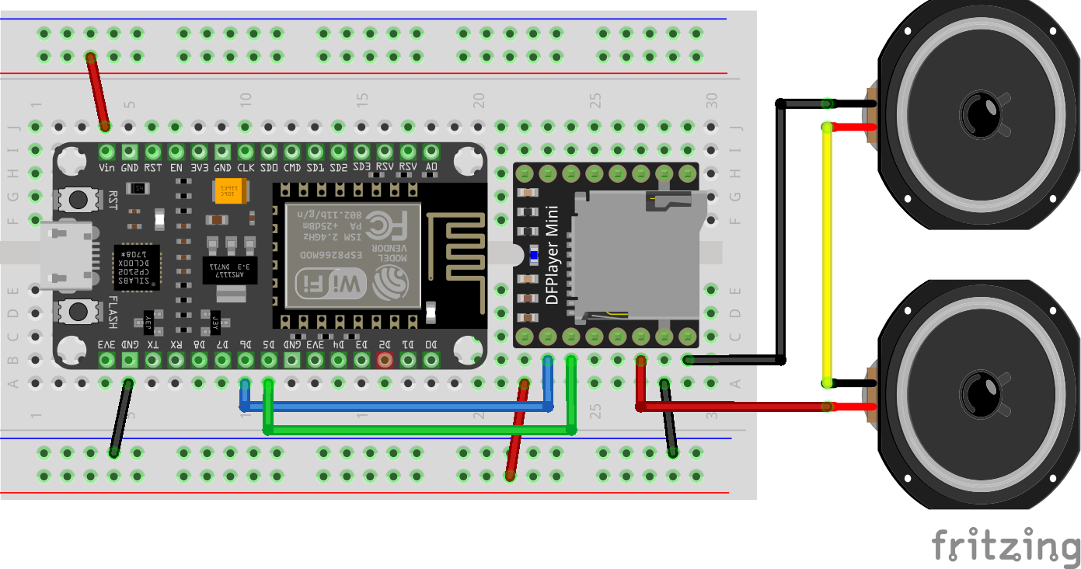

Sound Files
The biggest trick to the DFPlayer Mini is naming sound files correctly and putting them into properly named directories. There is a lot of information that can be found by searching, but I found the following structure to work well:

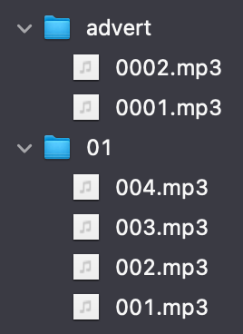

The code tells the DFPlayer to play all files in the folder 01 in a continuous loop. The override commands tell the DFPlayer to play advertisements named 1 or 2 in the advert folder.

JMRI MQTT Setup
It was not initially clear to me exactly how to setup MQTT in JMRI. It turns out that MQTT is added as another connection, alongside your normal layout connection(s) as shown in this Preferences view. Since I am running the MQTT server on the same Raspberry Pi where JMRI is running, the IP Address is set to “localhost”. Checking the option to show Additional Connection Settings will reveal all of the topics used by JMRI. The topics shown in this screenshot are the current defaults for JMRI; earlier versions of JMRI had different defaults. The only ones I am currently using are the ones for Turnouts. You can change these values, but the topics will also need to be changed in the code running on the ESP chip.

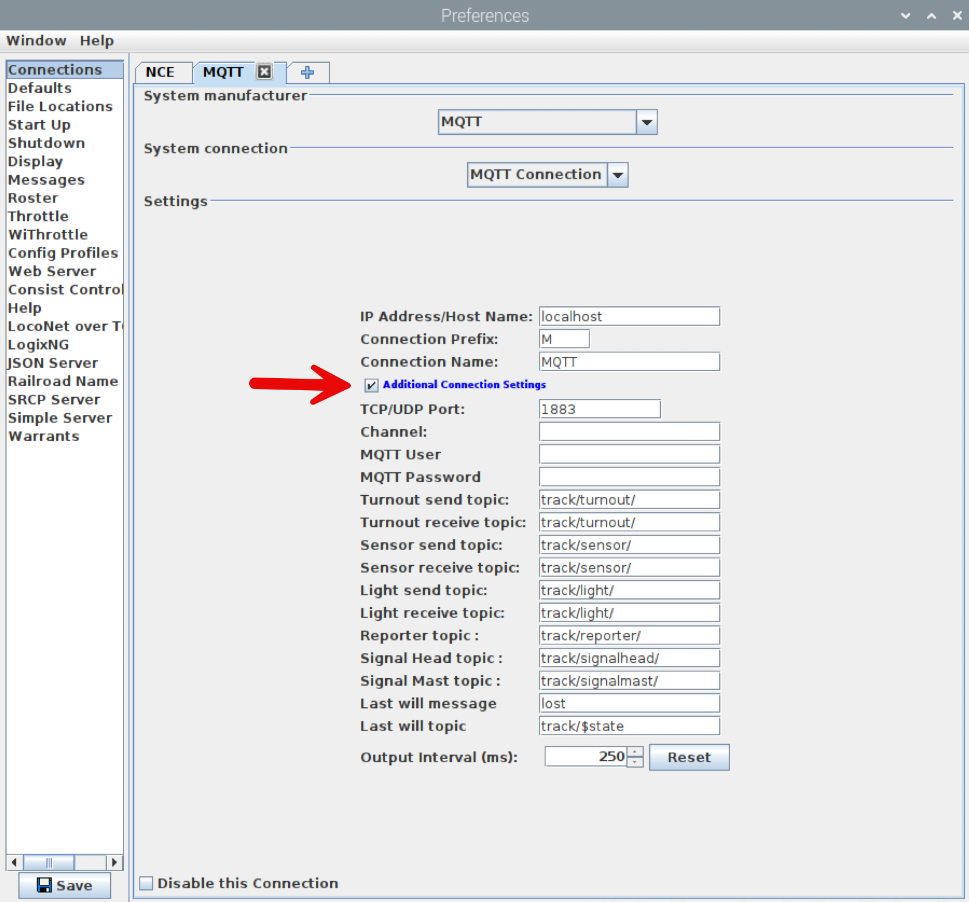
MQTT Setup on Raspberry Pi
The MQTT broker can be run on any convenient computer, but given the extremely small volume of MQTT messages and the relatively small size of my layout and JMRI setup, the Raspberry Pi has plenty of resource to also run an MQTT broker. The following commands are used to install the Mosquitto MQTT broker and clients (for testing) on a Raspberry Pi:

sudo apt update && sudo apt upgrade
sudo apt install -y mosquitto mosquitto-clients
sudo systemctl enable mosquitto.service

Code
The ESP8266 can be programmed with the Arduino IDE just like any Arduino chip. I chose to use PlatformIO as a VS Code Extension instead because I develop software professionally. Either option will work. The complete source code can be downloaded from the Tulsa NMRA website:
https://www.tulsanmra.org/resources/mp3-mqtt-PIO.zip

A few key areas are discussed below.

MP3 Playback
The code that runs the MP3 player is very standard. Note that a software serial device is used since the ESP8266 does not have a hardware serial device. The key playback element is the call loopFolder(1) to continually loop through all sound files in folder “01”.
SoftwareSerial mySoftwareSerial(14, 12); // RX, TX
DFRobotDFPlayerMini myDFPlayer;

mySoftwareSerial.begin(9600);
myDFPlayer.begin(mySoftwareSerial)) //Use softwareSerial to communicate with mp3.
myDFPlayer.setTimeOut(500); //Set serial communictaion time out 500ms
myDFPlayer.volume(soundVolume); //Set volume value (0~30).
myDFPlayer.EQ(DFPLAYER_EQ_NORMAL);
myDFPlayer.outputDevice(DFPLAYER_DEVICE_SD);
myDFPlayer.loopFolder(1);

MQTT Subscription
There are several layers to using MQTT, but the basic steps are to connect to the MQTT broker and register a callback for any messages that are sent. It is up to our code to parse the incoming messages to determine if they are for us, and to process them if so. The code shown in receivedCallback() below plays ads (which I use for thunderstorms) or sets volume if the appropriate messages are received.
static const char* host = CONFIG_HOST_IP;
static const int port = 1883;
static WiFiClient wifi_client;
static PubSubClient mqtt_client(wifi_client);
mqtt_client.setServer(host, port);
mqtt_client.setCallback(receivedCallback);

void receivedCallback(char* topic, byte* payload, unsigned int length)
{
//if we got a message on the ad topic, process it
if (strcmp(topic, ad_topic) == 0)
{
//unless it is the first one, which was retained in the MQTT server
if (isFirstAdMsg)
{
isFirstAdMsg = false;
}
else
{
int adNum = 0;
if (strncmp((char*)payload, ad1_msg, strlen(ad1_msg)) == 0)
{
adNum = 1;
}
else if (strncmp((char*)payload, ad2_msg, strlen(ad2_msg)) == 0)
{
adNum = 2;
}

if (adNum > 0)
{
myDFPlayer.advertise(adNum);
}
}
}
//if we got a message on the volume topic, process it
else if (strcmp(topic, vol_topic) == 0)
{
//unless it is the first one, which was retained in the MQTT server
if (isFirstVolMsg)
{
isFirstVolMsg = false;
}
else
{
int newSoundVolume = soundVolume;
if (strncmp((char*)payload, volup_msg, strlen(volup_msg)) == 0)
{
newSoundVolume += 1;
}
else if (strncmp((char*)payload, voldn_msg, strlen(voldn_msg)) == 0)
{
newSoundVolume -= 1;
}

if (newSoundVolume < 0)
{
newSoundVolume = 0;
}
else if (newSoundVolume > 30)
{
newSoundVolume = 30;
}

//if we have a new volume, use it
if (newSoundVolume != soundVolume)
{
soundVolume = newSoundVolume;
myDFPlayer.volume(soundVolume);

//store the volume for the next restart
EEPROM.put(VOL_EEPROM_ADDR, soundVolume);
EEPROM.commit();
}
}

Persisting Volume Between Reboots
In order to preserve the last set volume when the device is powered off and restarted, I store the last volume value in simulated EEPROM, using a library that uses the memory efficiently.

//get the initial volume
#define VOL_EEPROM_ADDR 0

EEPROM.begin(16);

//only read if something has been written
if (EEPROM.percentUsed() >= 0)
{
EEPROM.get(VOL_EEPROM_ADDR, soundVolume);
}

//store the volume for the next restart
EEPROM.put(VOL_EEPROM_ADDR, soundVolume);
EEPROM.commit();

Libraries
I used the following libraries in my code:
ESP8266WiFi - used to connect to Wi-Fi network
PubSubClient - used to subscribe to MQTT topics
DFRobotDFPlayerMini - used to control DFPlayer Mini
ESP_EEPROM - used to store the latest volume setting in simulated EEPROM efficiently

Other Options
The circuit above, or the equivalent with any Arduino, can be used to play background sounds with no overrides.

There is no requirement to use JMRI or a throttle to trigger the override sounds. Any MQTT publisher can send the MQTT messages that trigger sounds and change volume levels.

There is no requirement to use MQTT to trigger the override sounds. While experimenting with the ESP 8266 I was able to setup a web server on it that I could hit with my cellphone. In my test I was controlling LEDs using a simple web page, but it could just as easily trigger sounds and adjust the volume.

Resources
DFPlayer Mini documentation:
https://wiki.dfrobot.com/DFPlayer_Mini_SKU_DFR0299

ESP8266 Pin Info:
https://randomnerdtutorials.com/esp8266-pinout-reference-gpios/

Parts
ESP8266 NodeMCU, less than $6 each in qty 3:
https://www.amazon.com/gp/product/B081CSJV2V

DFPlayer Mini:
https://www.dfrobot.com/product-1121.html
Also check Amazon:
https://www.amazon.com/DFPlayer-A-Mini-MP3-Player/dp/B089D5NLW1

Speakers, CQRobot 4 Ohm speakers:
https://www.amazon.com/gp/product/B0822Z4LPH

Solderable breadboard:
https://www.amazon.com/gp/product/B07ZYNWJ1S

Photos

